Pre-Reading

Self-Introduction
When introducing yourself in Chinese, 叫 (jiao4) is often used to tell someone your name, it literally means to call. So, 我 (wo3) 叫 means I am called. The character 叫 is made of two radicals 口 and 丩. 口 (kou3) means mouth, so here it is meaning an action that uses your mouth. 丩(jiu1) this radical is telling us that he character will start with the English “J” sound. As you learn more characters and more radicals you will start to recognize patterns for which radicals are phonetic components and which radicals are meaning based. Following this sentence you see 可以 (ke3yi3) which means “can or may.” After the second “Fred” you will see the characters 老师 (lao3shi1). 老 meaning old or ancient and 师 meaning master or expert combine to make teacher, so this literally means Fred Teacher. In China you often address people with their family name and position title. For example, you might call your doctor 张医生（zhang1yi1sheng1）, which again literally means Zhang Doctor or Doctor Zhang. With English names surnames or given names are both accepted. In the next line you will see the word 汉语 (han4yu3), which means Chinese (the language). The character 汉 is also the character for Han Chinese, an ethnic group which makes up nearly 92% of the population in mainland China. The other character is 语 which simply means language, so 英语 (ying1yu3) is the English language and 法语 (fa3yu3) is the French language. This character is also divided into two components the left side signifies language whereas the right side is the phonetic component. The next major word that needs to be addressed is 喜欢 (xi3huan1), which means “to like,” so for example if you say “我喜欢apples,” it means “I like apples.” In this story there are three things that the writer either likes or doesn’t like. They are 篮球 (lan2qiu2), 看书 (kan4shu1), and 逛街 (guang4jie1). The first word 篮球is divided into two characters the first one is 蓝which means basket, the second character 球means ball or circular. So, you can guess that 篮球means basketball. The verb here is 打 (da3) which means to hit, or push. In this case “hit the basketball” actually means play basketball. If you say 打我, however it means “hit me” or 我不打你, which means “I don’t hit you.” The next word 看书 also has two characters, the first being 看, which means to see or to look at. So you could say 看我， or 看老师， or even 看篮球. The second character is 书, which means book. So again you assume that 看书does not mean to look at a book, but to read a book. The last one 逛街is composed of 逛 and 街. 逛means “to take a stroll“, where as 街 means “street.” This one may be a little more difficult to guess, but if you can imagine in ancient China what people were doing when they strolled down the street, then you might guess that it means to go shopping. Finally, the last thing you’ll need to know is the character 不 (bu4) this character means “no.” So, if I say 我不叫Bob, 我叫Fred, it means “I am not called Bob, I am called Fred.” Pay attention to this character because the tones change depending on the following character.
Story Character Count = 38
Vocabulary/Writing

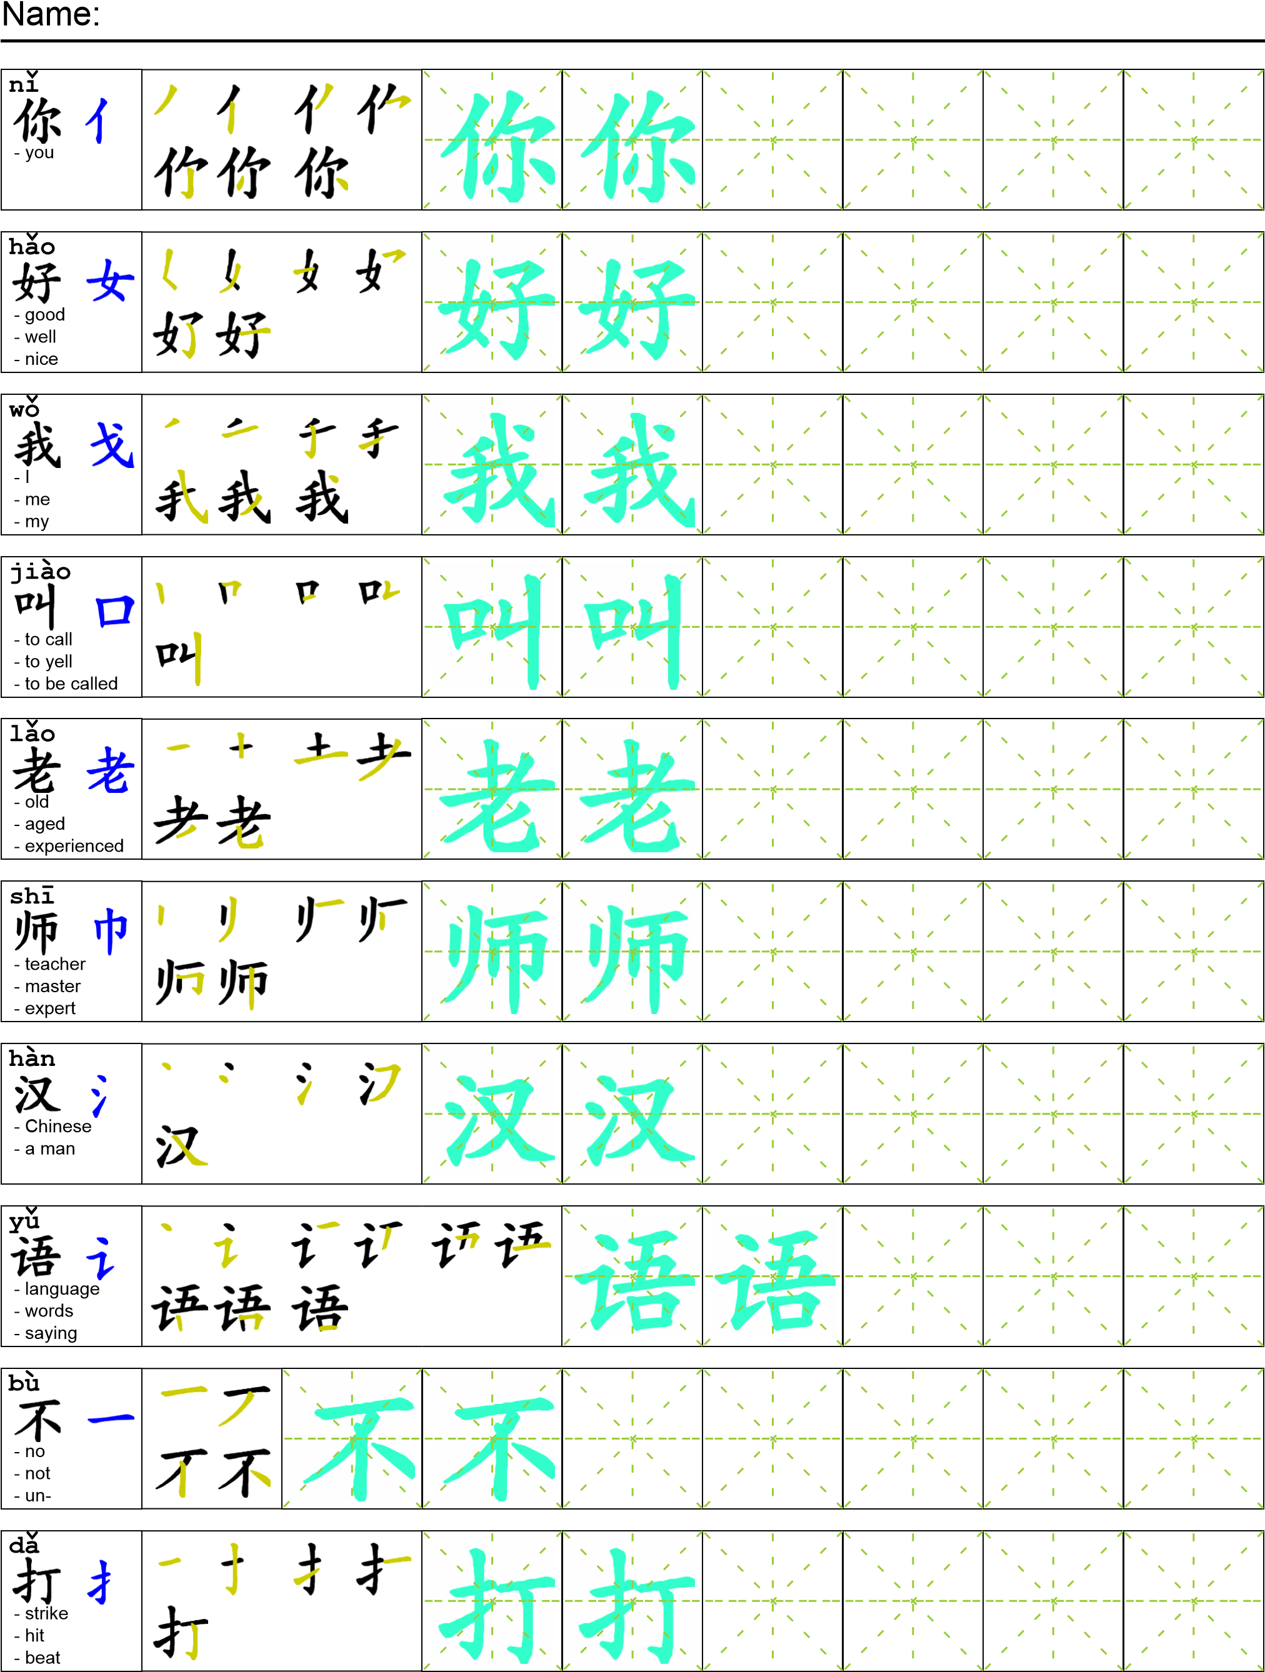
Reading

你好，我叫Fred.你可以叫我Fred老师。我是一个汉语老师。我喜欢打篮球和看书。我不喜欢逛街。
Task Completion

Once all tasks are complete turn the assignment in to collect the points for the project.
Task 1: Trace the vocabulary and copy the story into your notebook.

Task 2: Answer Comprehension Questions

Task 3: Write the Pinyin for the Reading

Task 4: Translate the Reading into English

Task 5: Record yourself reading the passage.

Comprehension Questions
- What does Fred like ？_____________________________________________________________
- What doesn’t Fred Like？___________________________________________________________
- What is Fred’s Job? ________________________________________________________________
- Give me another example of how to use 看 _____________________________________________
- What does 汉 mean? ________________________________________________________________

